Introduction
In urban environments heavily reliant on public transport, the reliability of commuting routes significantly impacts residents’ daily lives and work efficiency. Particularly in large cities like London, where the underground and rail networks form the backbone of the city’s mobility, transport delays or service disruptions not only cause immediate time losses but may also influence long-term travel decisions and the overall commuting experience. Consequently, identifying potential route disruption risks in advance has become a critical concern within the field of intelligent transport systems.
This project aims to develop an AI-Enhanced Route Forecaster system to address this challenge. By using historical commuting behaviour, temporal characteristics, transport route information, and environmental factors, it predicts the likelihood of daily route disruptions. Through identifying key factors influencing commuting disruptions—such as peak-hour congestion or adverse weather—the system provides users with more forward-looking route risk assessments before travel, supporting more rational and efficient commute planning.
The dataset employed in this project integrates multiple dimensions of information, including user commuting patterns, space and time-specific characteristics, route reliability, and weather conditions. The project focuses on applying machine learning and data analytics techniques to explore the relationships between various factors and commuting disruptions. It constructs predictive models with interpretability to deliver data-driven insights for intelligent travel decision making and urban traffic management.

Dataset Description
This project utilizes two complementary datasets: Commute Records and User Profile. These datasets are merged using the User_id field to create a comprehensive view of commuting behaviours and preferences, allowing for a more nuanced analysis of how individual habits interact with system-wide performance.

1. Commute Records Dataset
This is a 1,500-row and 13-column dataset, where each row represents a single complete commuting journey undertaken by one user on a given day. Each column within the dataset denotes specific attributes relating to commuting behaviour, time characteristics, space information, transport routes, and environmental conditions. This dataset comprises synthetic data, designed with reference to the operational characteristics of London’s public transport system, for analysing and predicting potential disruptions to commuting routes. Below is an overview of the dataset’s columns:
- User_id: A unique identifier for commuting users.
- Date: The specific date on which the commute occurred, indicating travel behaviour within the time dimensions.
- Day_of_week: Information regarding the day of the week corresponding to the commute date.
- Hour_of_day: The hour (0–23) when the commute commenced, critical for identifying rush-hour patterns.
- Is_peak_hour: Binary, whether the commute occurred during peak hours (1 = peak period, 0 = off-peak period).
- Start_zone: The commuting origin zone.
- End_zone: The destination zone.
- Distance_km: Estimated commute distance (in kilometres).
- Is_rainy: Weather condition variable indicating whether it rained on the commute day (1 = rainfall, 0 = no rainfall).
- Avg_trip_time_min: Average commute duration (in minutes).
- Line_id: Name of the primary public transport line used for this commute (e.g., Central, Northern, Elizabeth), allowing for line-specific reliability analysis.
- Historical_delay_rate: A numerical indicator of a line’s historical delay rate.
- Route_status: The target variable, indicating whether the commute experienced route disruption or significant delay (1 = disruption occurred, 0 = normal operation).

2. User Profile Dataset
This dataset contains 30 rows and 6 columns, representing static profiles for each of the 30 unique users tracked in the commute records. It provides context about the users’ typical commuting preferences and allows for feature engineering (e.g., checking if a user is taking their primary line or an alternative).
- User_id: Unique identifier to link with the Commute Records.
- Home_zone: The user’s residential zone.
- Work_zone: The user’s workplace zone.
- Primary_line: The public transport line the user prefers to take.
- Backup_line: An alternative line the user might take.
- Usual_hour: The typical hour of day the user starts their commute.

Exploratory Data Analysis (EDA) Findings

Feature Correlation Matrix for Commuting Route Disruption Prediction
This correlation heatmap shows the relationships between various features in the commuting dataset and the target variable Route_status. The results showed a strong positive correlation between commuting distance (Distance_km) and average commuting time (Avg_trip_time_min), consistent with travel patterns observed in real commuting situations.
Regarding route disruptions, the most significant correlation is observed between Is_peak_hour and Route_status, though overall it remains medium to weak. This suggests that while peak hours are a factor, they are not the sole determinant of delays. Additionally, Is_rainy shows a slight positive correlation with route disruptions. The remaining variables have weak or close to zero correlations with route disruptions, indicating that commuting disruptions are not determined by a single factor but result from the combined influence of multiple factors.
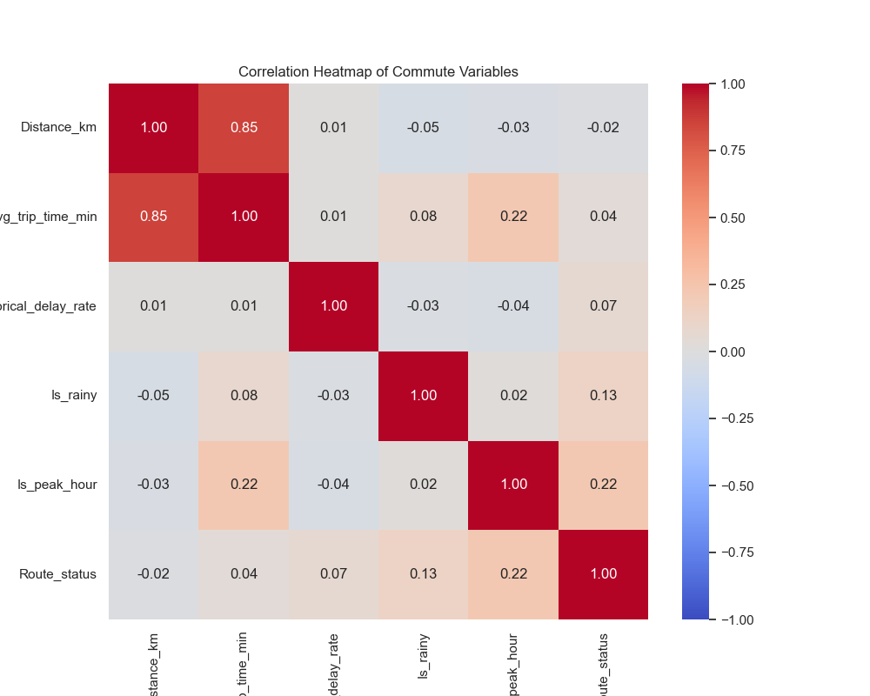
Figure 1 - Feature Correlation Matrix

Categorical Variables
These charts show the distribution of the main categorical variables in the dataset. Each sub chart reflects the distribution of commuting records across different categories.
The results indicate that commuting records are generally distributed evenly throughout the week, with no significant extreme concentrations. Regarding transport route distribution, the Central, Jubilee and Northern lines are used more frequently, reflecting the dependency on mainline routes for London commuting. The target variable Route_status indicates that most commuting records were on time, with delays accounting for a relatively low proportion, consistent with realistic commuting scenarios. Regarding origin zones, commuting frequency in Zones 2 and 3 is slightly higher than in other zones, reflecting the travel characteristics of the core commuting zone.
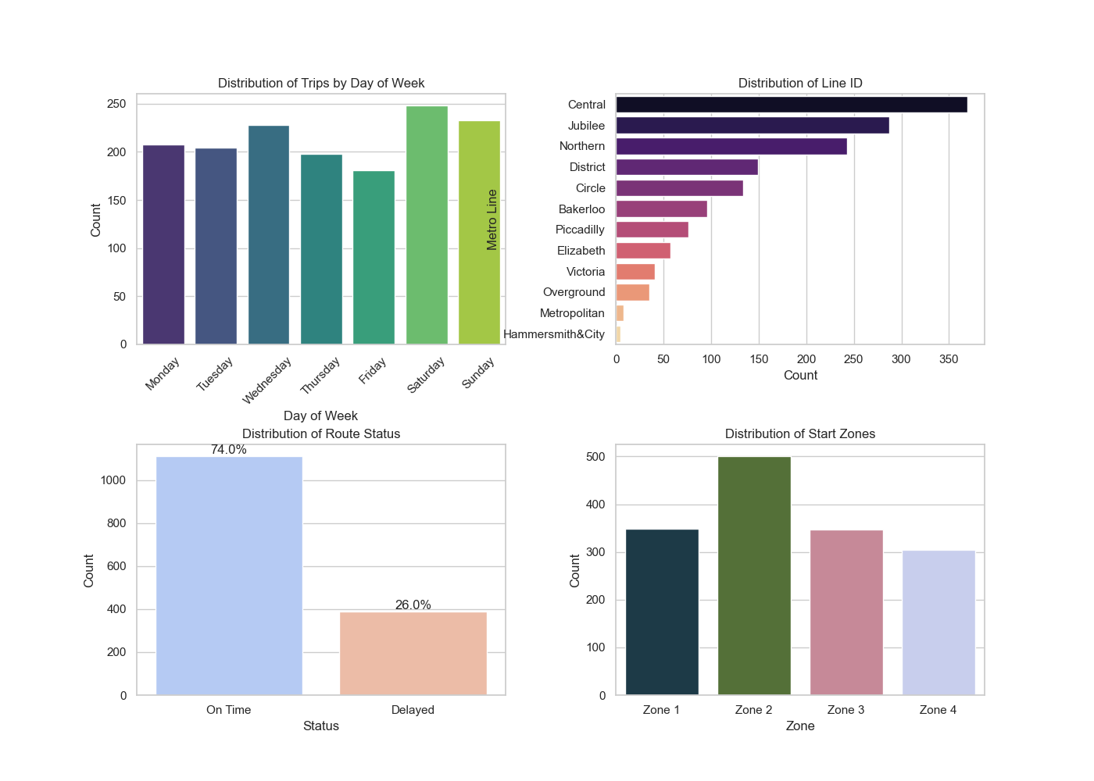
Figure 2 - Categorical Variables Analysis

Analysis of Commute Punctuality and Delay Proportions
This pie chart illustrates the distribution of punctual versus delayed commutes along various routes. Results indicate that approximately 26% of commuting records experienced delays, while 74% remained on time, suggesting that service disruptions represent a relatively infrequent but significant occurrence within the overall commuting pattern. For this project, the focus lies in identifying high risk commuting scenarios where delays are likely to occur, to provide alerts and route optimisation suggestions before travel, rather than focusing on the majority of on time commuting records.
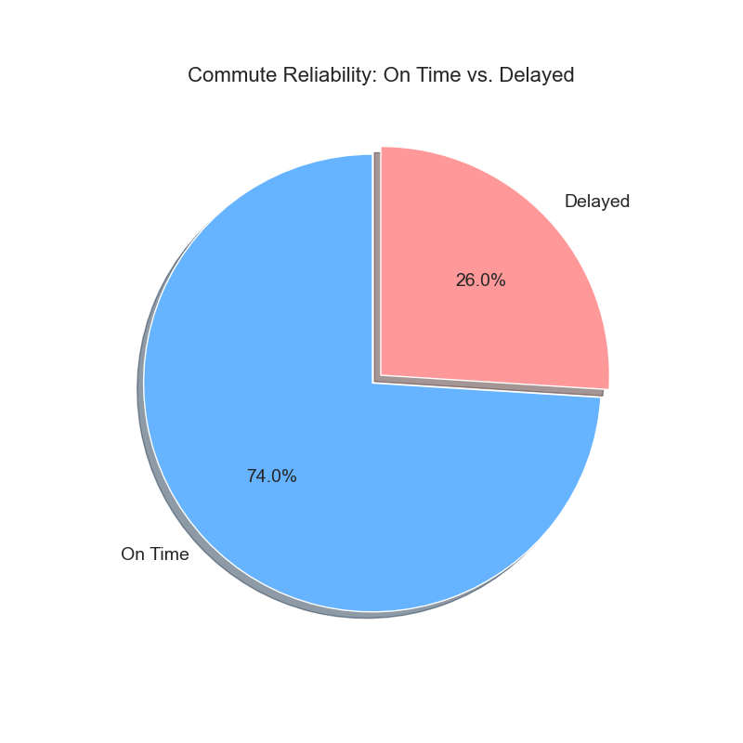
Figure 3 - Commute Reliability

Analysis of Factors Influencing Commuting Duration
Looking at the below multiple box plots, commuting times differ significantly across different underground lines and starting areas, while the distribution of commuting times across different days of the week is similar overall. This confirms that spatial factors (which line and which zone) are stronger determinants of trip duration than the specific day of the week.
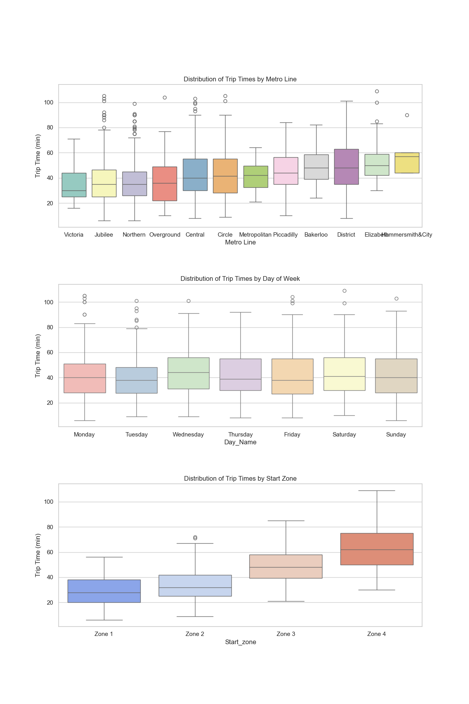
Figure 4 - Distribution of Trip Times

Feature Engineering and Model Implementation

Feature Engineering
Feature Selection: Some variables were removed because they do not help explain whether a route is delayed. The User_id and Date fields were dropped since they only act as identifiers and do not provide useful information for prediction. Variables that were only used during data generation were also removed to avoid overfitting and possible data leakage.
Encoding Categorical Data: Categorical variables such as metro lines and start zones were converted using one-hot encoding. This method treats each category independently and avoids creating an artificial order between categories. Label encoding was considered, but one-hot encoding was found to be more suitable for this task, as it prevents the model from assuming, for example, that Zone 2 is “greater than” Zone 1.
Handling Missing Values: No missing values were found in the dataset. However, a general rule was included in the process: rows with missing categorical values would be removed, and missing numerical values would be replaced with the mean.
Feature Transformation: Numerical features were standardised so that they have similar scales. This helps prevent any single feature from having too much influence on the model and improves training stability.
Balancing the Dataset: The dataset is imbalanced, with more on-time journeys than delayed ones. To address this, SMOTE (Synthetic Minority Oversampling Technique) was used to increase the number of delayed samples. This method creates new samples based on nearby existing ones rather than copying old data, which helps reduce overfitting and improve model performance.

Model Implementation
Four supervised learning algorithms were selected to predict route disruptions: Decision Tree, Random Forest, XGBoost, and Logistic Regression. These models were chosen because they are commonly used for binary classification tasks and allow for comparison between simple and more complex approaches.
Decision Tree A decision tree is a rule-based model that splits the data into different branches based on feature values. Each split represents a decision, and each leaf node produces a prediction indicating whether a route is disrupted or not. Decision trees are easy to understand and interpret, making them suitable as a baseline model for this task (Kapil, 2022).
Random Forest Random Forest is an ensemble learning method that builds multiple decision trees independently and combines their predictions to produce a final result. This approach reduces overfitting and improves model stability compared to a single decision tree. Random Forest performs well on structured datasets and can also provide information about feature importance (IBM).
XGBoost XGBoost is a boosting-based ensemble algorithm that builds decision trees sequentially, where each new tree focuses on correcting the errors made by previous ones. Due to its strong performance on tabular data, XGBoost was included to evaluate whether a more advanced model could improve prediction accuracy (Bentéjac et al., 2019).
Logistic Regression Logistic regression is a statistical model commonly used for binary classification problems. It estimates the probability of route disruption by applying a sigmoid function to a linear combination of input features. The model is simple, easy to implement, and interpretable, but it assumes a linear relationship between features and the target variable (Baladram, 2024).

Model Evaluation and Performance

Validation method
To assess how well the models perform on unseen data, the data set was split into 3 parts: - Training: 70% - Validation: 15% - Testing: 15%

Performance metrics
Model | Accuracy | Precision | Recall | F1 Score | AUC-ROC
Decision Tree | 0.7087 | 0.7299 | 0.7175 | 0.7236 | 0.7081
Random Forest | 0.7748 | 0.8000 | 0.7684 | 0.7839 | 0.8760
Logistic Regression | 0.6366 | 0.6489 | 0.6893 | 0.6685 | 0.7106
XGBoost | 0.7598 | 0.8050 | 0.7232 | 0.7619 | 0.8561
Table 1 - Performance Metrics
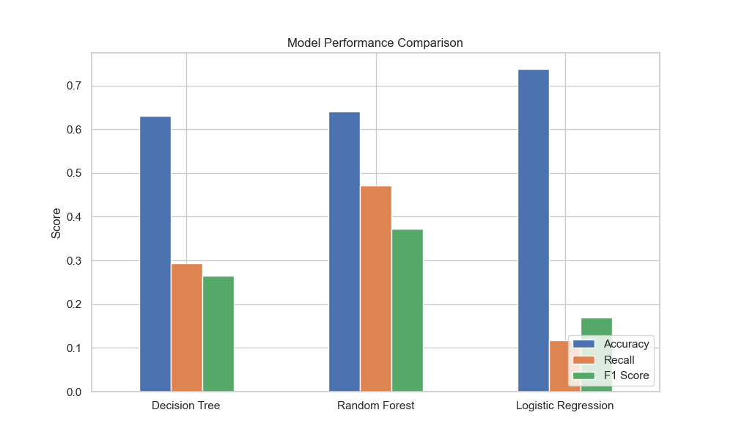
Figure 5 - Model Performance Comparison

Evaluation
When assessing these route disruption prediction algorithms, Recall is prioritised as a key metric. In the context of commuting, a False Negative (predicting “On Time” when a delay actually occurs) is more detrimental to the user experience than a False Positive (predicting “Delay” when it is on time), as it leads to unexpected lateness. However, overall Accuracy and F1 Score are also crucial for a balanced system.
Random Forest: As illustrated by the table above, the Random Forest algorithm proved to be the most successful model, achieving the highest Accuracy (0.7748), Recall (0.7684), and F1 Score (0.7839). It also achieved the highest AUC-ROC of 0.8760, demonstrating a robust ability to distinguish between disrupted and normal routes. Its ensemble nature likely helped it capture complex non-linear relationships without overfitting as much as the single Decision Tree.
XGBoost: The XGBoost algorithm performed strongly, coming in as the second-best model with an Accuracy of 0.7598 and an F1 Score of 0.7619. It had the highest Precision (0.8050), meaning it produced fewer false alarms than other models. However, its Recall (0.7232) was slightly lower than Random Forest, making it slightly less effective at catching every potential delay instance in this specific configuration.
Decision Tree: The Decision Tree provided a reasonable baseline with an Accuracy of 0.7087. While simple and interpretable, it underperformed compared to the ensemble methods (Random Forest and XGBoost), likely due to its tendency to overfit the training data and inability to generalize as well to unseen patterns.
Logistic Regression: Logistic Regression had the lowest performance across all metrics (Accuracy 0.6366, F1 Score 0.6685). This suggests that the relationship between the features (like time, zone, line) and the route status is non-linear and complex, which the linear logistic model failed to capture effectively.

Discussion and Interpretation
The findings highlight the effectiveness of ensemble learning methods for predicting transport delays. Random Forest emerged as the superior model, striking the best balance between identifying delays (Recall) and overall accuracy. This is likely due to its ability to handle high-dimensional categorical data (like Zones and Lines) and non-linear interactions (e.g., the effect of rain might depend on the line or time of day) more effectively than linear models.
XGBoost also showed strong potential, particularly in Precision, suggesting it is very confident when it does predict a delay. The feature importance analysis (derived from tree-based models) typically highlights variables such as Line_id, Hour_of_day, and Is_peak_hour as critical predictors. For instance, certain lines may have inherent structural delays, and peak hours naturally see more congestion-related disruptions.
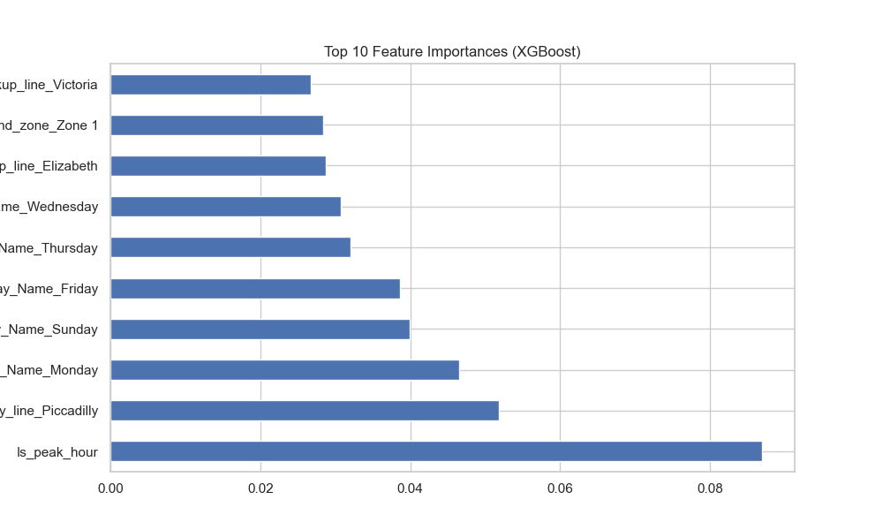
Figure 6 - Feature Importance
The underperformance of Logistic Regression confirms that simple linear combinations of features are insufficient for this problem. Commuting patterns involve complex dependencies—for example, a “Rainy” condition might drastically increase delay probability on surface-level lines but have little effect on deep underground lines. Tree-based models like Random Forest and XGBoost can naturally learn these conditional rules.

Conclusion and Future Directions
This project successfully developed predictive models to forecast commuting route disruptions, with Random Forest achieving the highest performance metrics. The model demonstrates that it is possible to predict potential delays with reasonable accuracy using historical data, time, and environmental factors.
Future directions to enhance this system could include: 1. Real-time Data Integration: Incorporating live API feeds (e.g., TfL Open Data) for real-time signal failures or accidents would significantly boost immediate prediction accuracy. 2. Granular Weather Data: Instead of a binary “Rainy” flag, using hourly precipitation levels could refine the environmental impact analysis. 3. Social Media Sentiment: Integrating text analysis from social media (e.g., Twitter/X) could provide early warnings of delays before they are officially reported. 4. Deep Learning: Exploring LSTM (Long Short-Term Memory) networks to better capture temporal dependencies in sequential time-series data.
These steps would transition the model from a static historical analysis tool to a dynamic, real-time intelligent travel assistant.

Bibliography
- Baladram, S. (2024, November 30). Logistic regression, explained: A visual guide with code examples for Beginners. Medium. https://towardsdatascience.com/logistic-regression-explained-a-visual-guide-with-code-examples-for-beginners-81baf5871505
- Bentéjac, C., Csörgő, A., & Martínez-Muñoz, G. (2019). A Comparative Analysis of XGBoost. ResearchGate. https://www.researchgate.net/publication/337048557_A_Comparative_Analysis_of_XGBoost
- GeeksforGeeks. (2021, September 18). XGBoost. https://www.geeksforgeeks.org/xgboost/
- IBM. What is Random Forest? https://www.ibm.com/topics/random-forest
- Kapil, A. R. (2022, October 1). Advantages and disadvantages of decision tree in machine learning. Blogs & Updates on Data Science, Business Analytics, AI Machine Learning. https://www.analytixlabs.co.in/blog/decision-tree-algorithm/
- Scikit-learn. Logistic Regression. https://scikit-learn.org/stable/modules/linear_model.html#logistic-regression

